

**UNIVERSITI TEKNOLOGI MARA (UiTM)**

**CAWANGAN MELAKA KAMPUS JASIN**

**USER MANUAL: PIZZA ORDERING SYSTEM**

**Made By: PIZZA FRENZY**

**Group Members:**

|  |  |
| --- | --- |
| **Name** | **Matric No.** |
| FIRMAN BIN FARDI | 2017518491 |
| NUR ANISA BINTI ZAHARUDIN | 2017313585 |
| NURSHAZWANI BINTI ABDUL WAHID | 2017787933 |
| SITI AISHAH BINTI ISMAIL | 2017745807 |

**Table of Contents**

|  |  |
| --- | --- |
| Contents | Page |
| Table of Contents | 3 |
| Snapshots of the System: Main Page | 4 |
| Snapshots of the System: Users | 5 – 11 |
| Snapshots of the System: Admin | 12 – 16 |
| Snapshots of the System: JSON file | 17 |

1. **INTRODUCTION**

Pizza Ordering system were develop by Pizza Frenzy group to ease the efficiency of when customer ordering pizza online or walk-in. The system give you all apps or feature in one system. For example,

There is maps or google maps ready for when customer needed to see where is the nearest pizza shop. Our system used many kind of framework for this system work efficiently like Cakephp,feathers,mySql.

**1.1 Main Page**

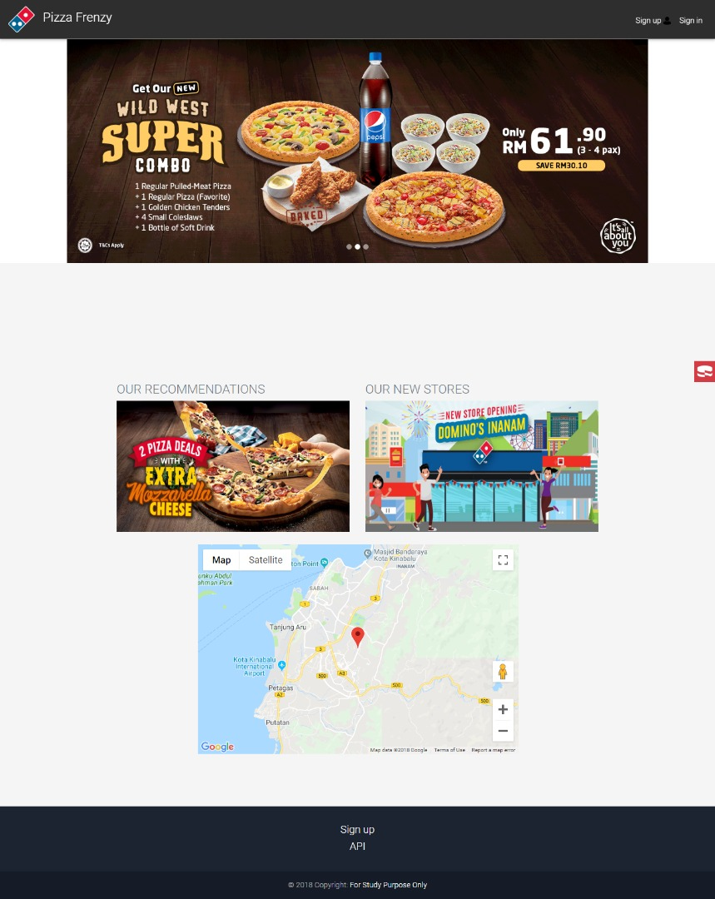

Figure 1.0 shows the main page of pizza frenzy. All users will redirect to this page first.

**1.2 Users**

1.2.1 Sign up page

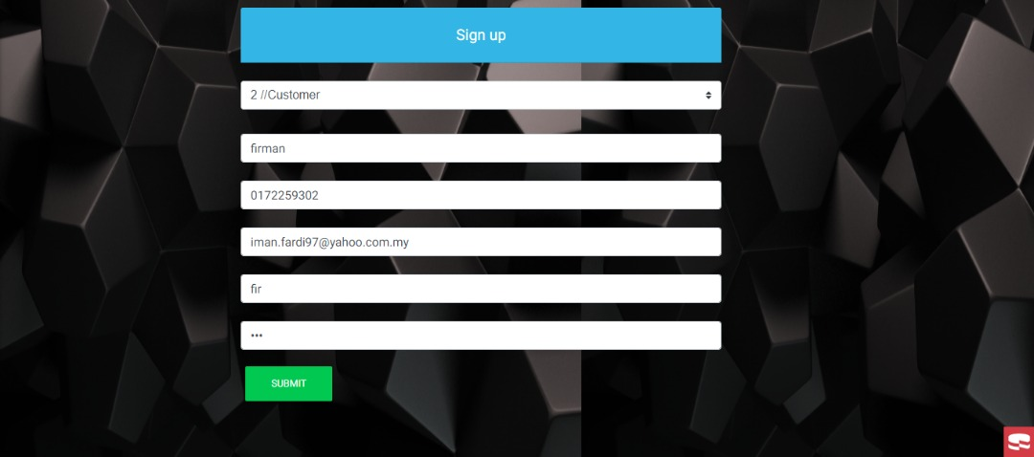

Figure 1.1 shows the sign up page. The users who do not have yet the account need to register first.

1.2.2 Login page

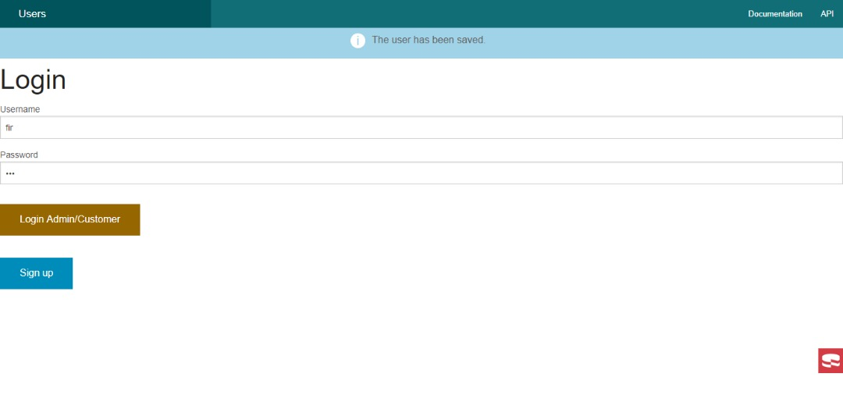

Figure 1.2 shows after the users have registered their account they will redirect to this page and needs to login first.

1.2.3 Main page after login

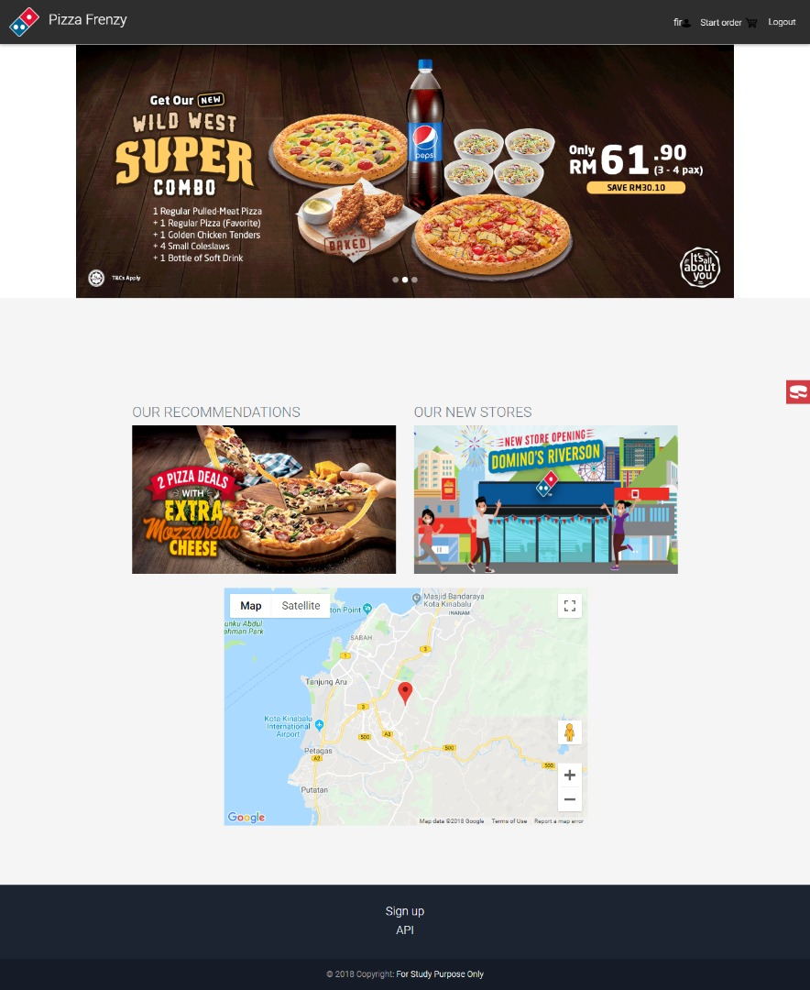

Figure 1.3 shows main page that will be redirect after the user login into the system. In this page will show the maps for the restaurant and recommendations of the menu.

1.2.4 Menu page

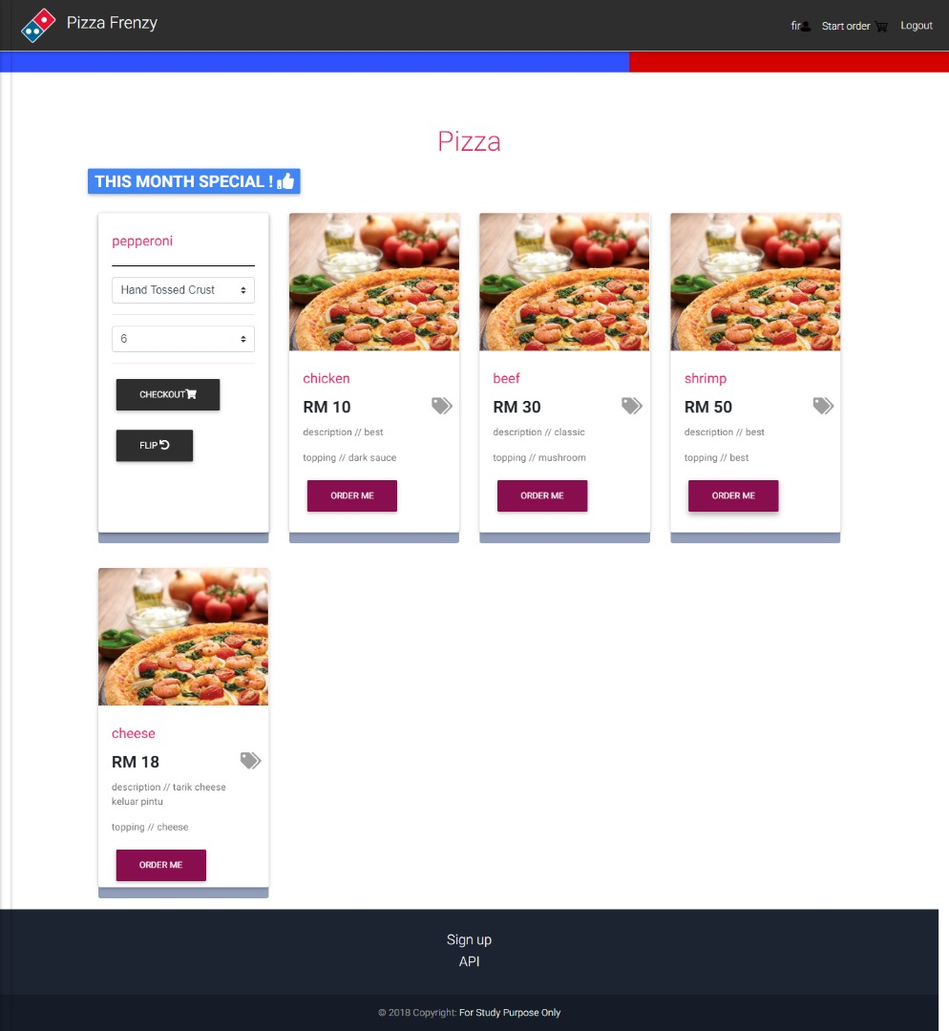

Figure 1.4 shows the menu page that the user can choose to order. In this page also stated the price for every pizza.

1.2.5 Payment page

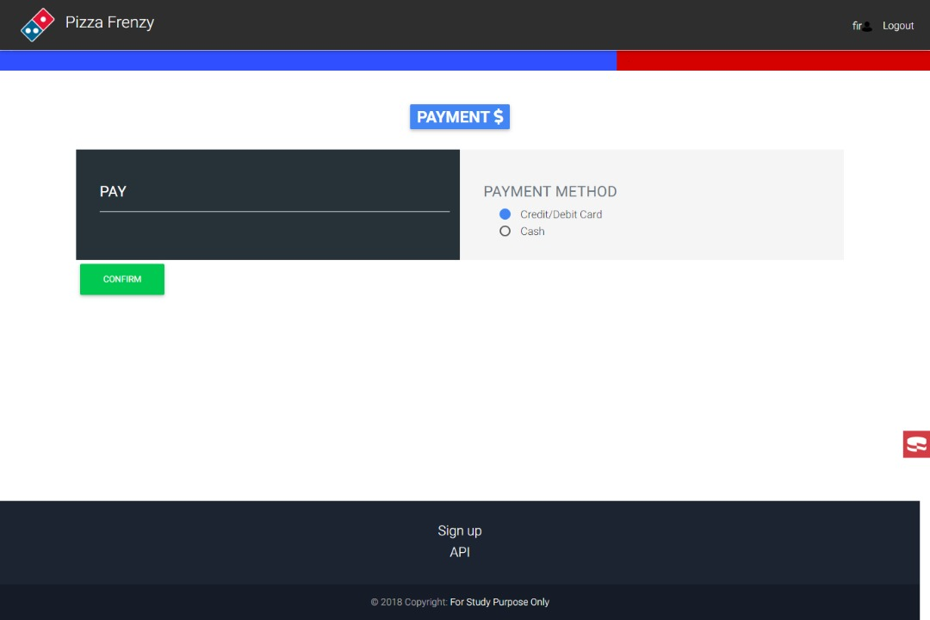

Figure 1.5 shows payment page. After the users have chosen the pizza then they will redirect to this page for payment. The users can choose type of payment method that they want either pay by cash or by credit/debit card.

1.2.6 Confirmation Order page

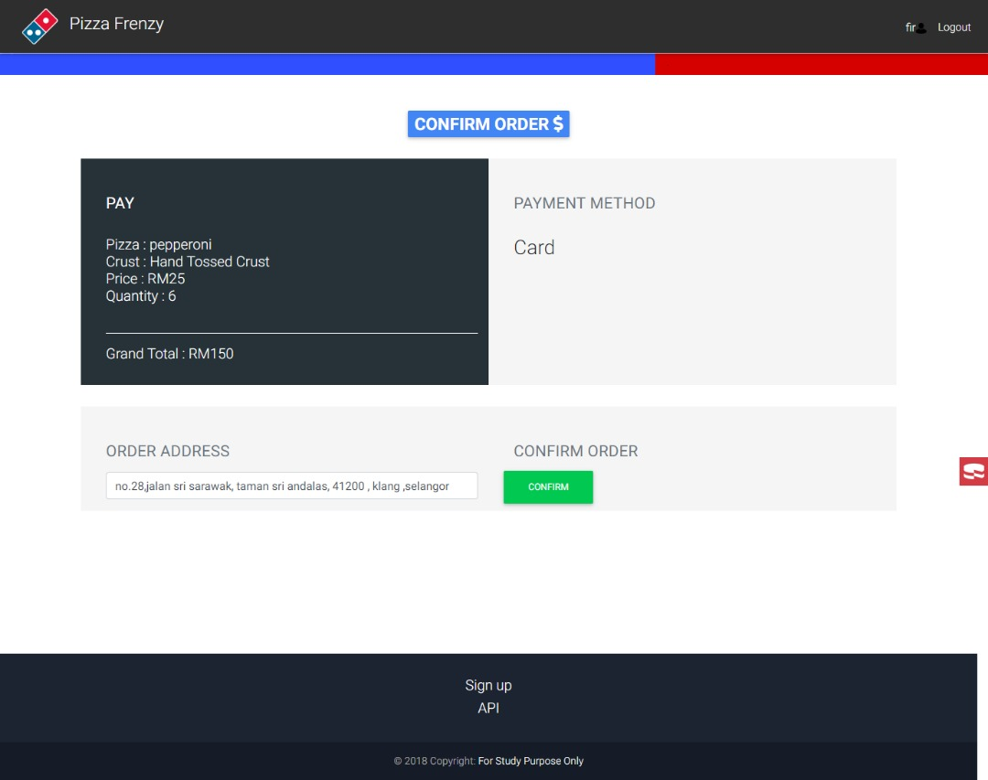

Figure 1.6 shows the confirmation page. After the users have chosen payment method they will redirects to this page for confirm their order and they need to fill up the address.

1.2.7 Successful page

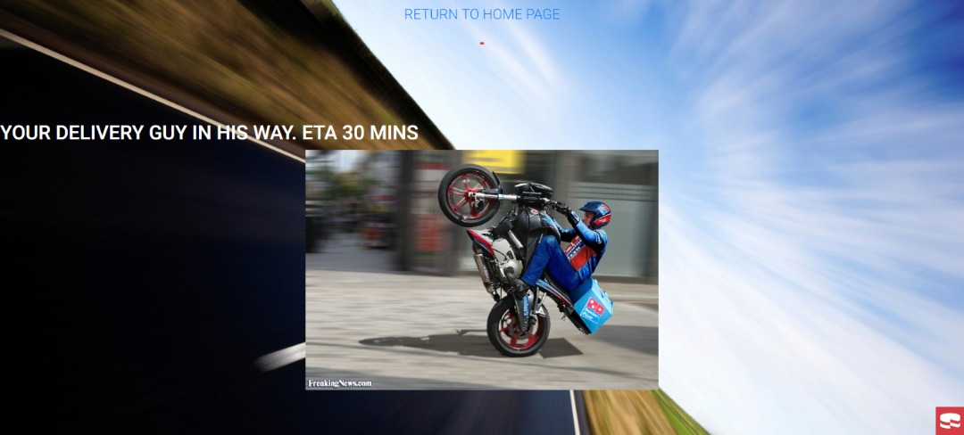

Figure 1.7 shows the successfully order page. This page means that users orders have been successfully and the pizza will delivered in 30 minutes.

1.2.8 API page

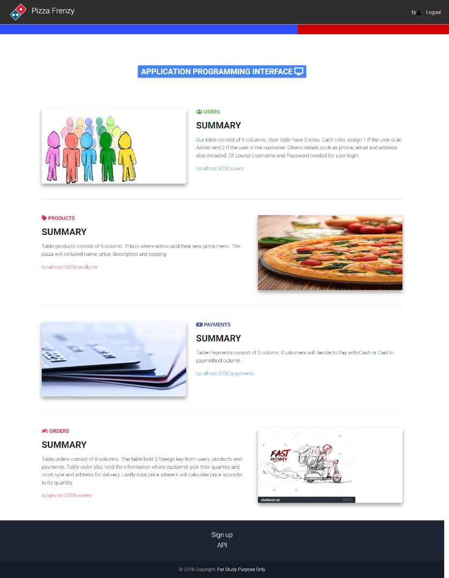

Figure 1.8 shows API page of the system.

**2.1 ADMIN**

2.1.1 Login page

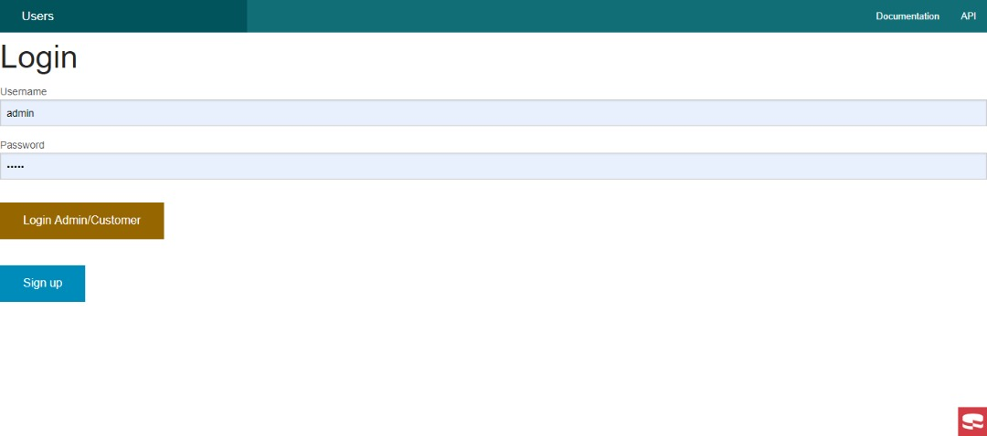

Figure 2.1 shows login page for admin. Admin needs to login first to alter or update something to the web page.

2.1.2 Product List page

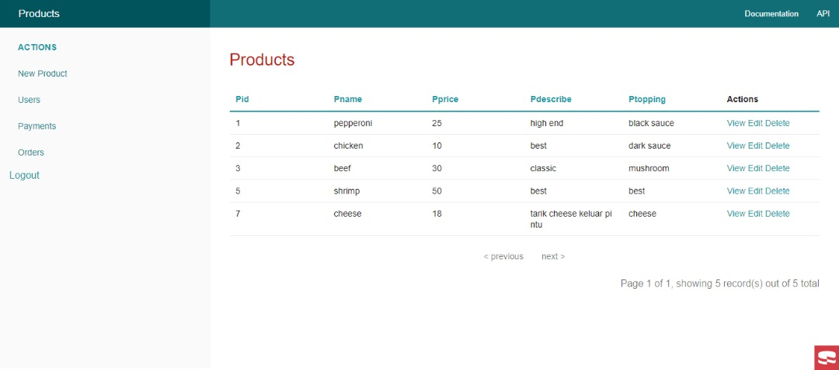

Figure 2.2 shows admin interface that provide all the information of the system. Admin can view the list for the product that available and edit the information also delete the information.

2.1.3 Orders List page

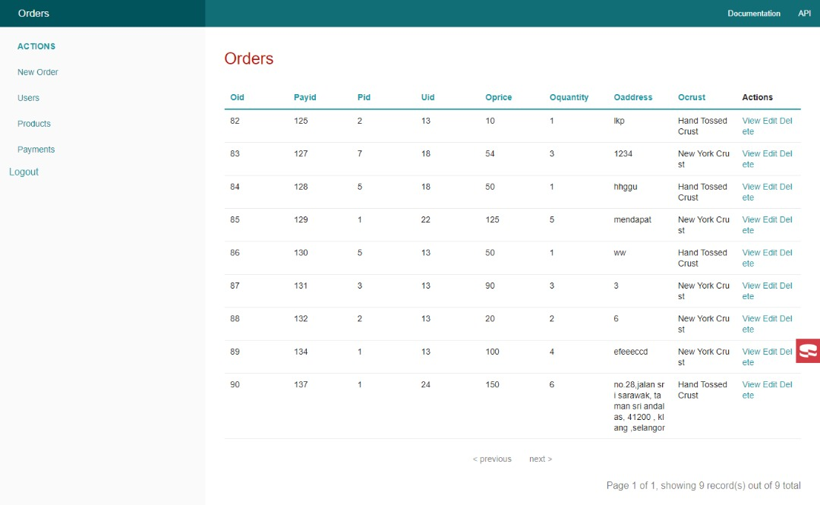

Figure 2.3 shows the ordering list that provided the information that admin can see order ID and Users ID for each ordering session.

2.1.4 Payments List page

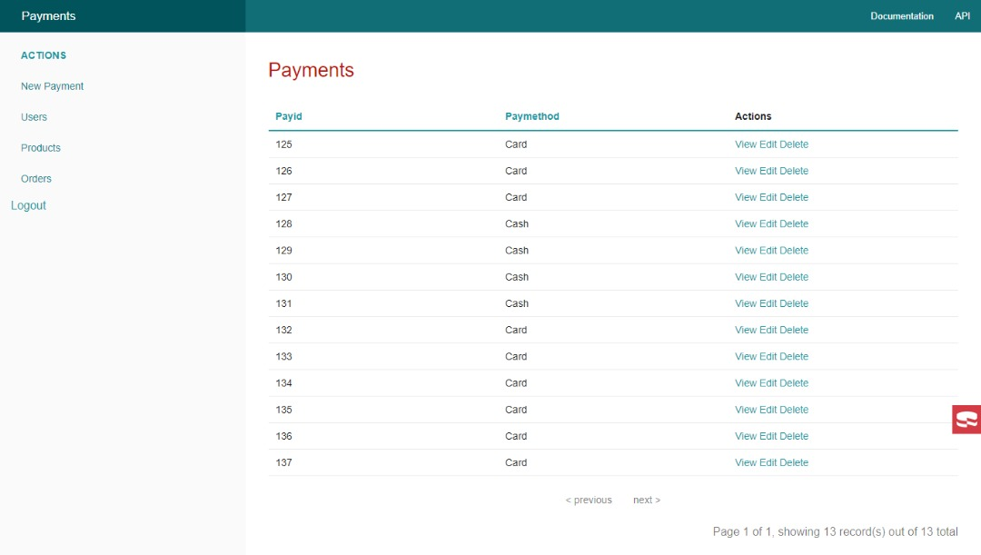

Figure 2.4 shows the information about payment method that users choose to use.

2.1.5 Users List page

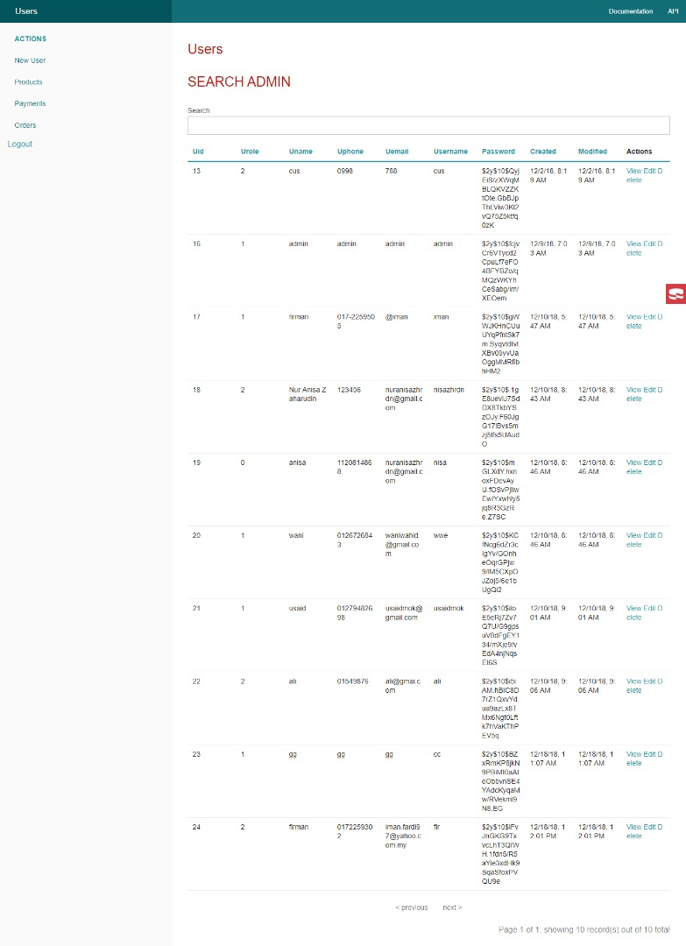

Figure 2.5.1 shows the list of users of the system.

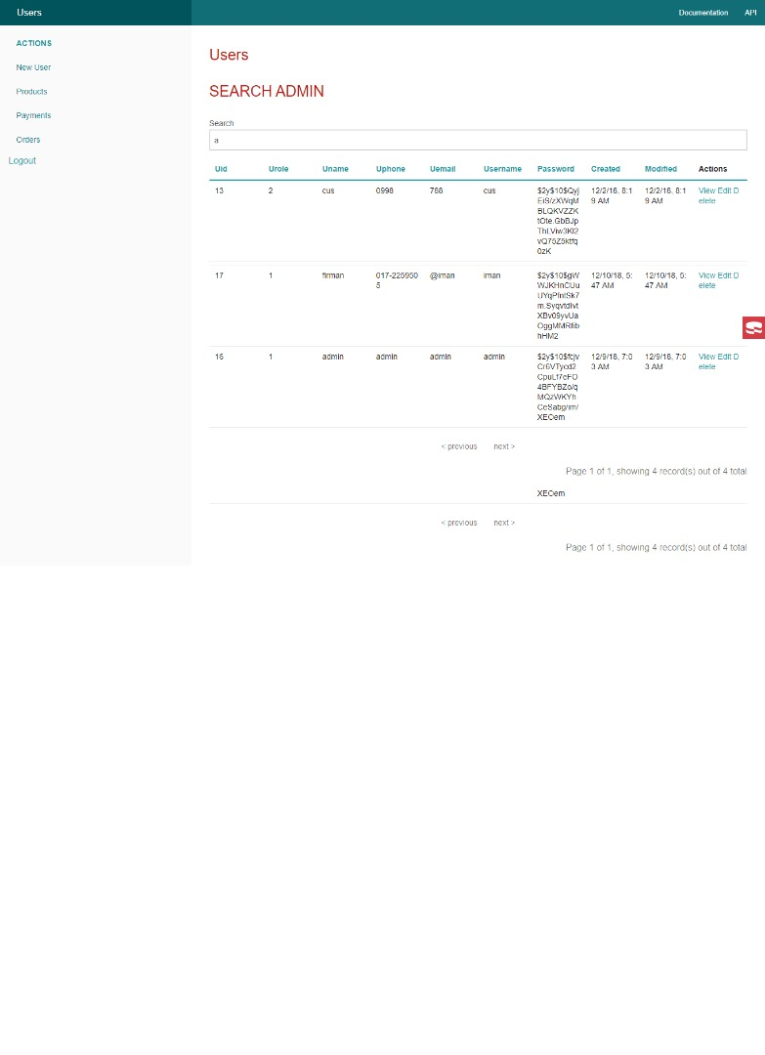

Figure 2.5.2 shows that the admin search for username that started with ‘a’. This system uses AJAX and it wills auto-search for searching.

3.0 Convert to JSON

This system is able to convert data into JSON file.

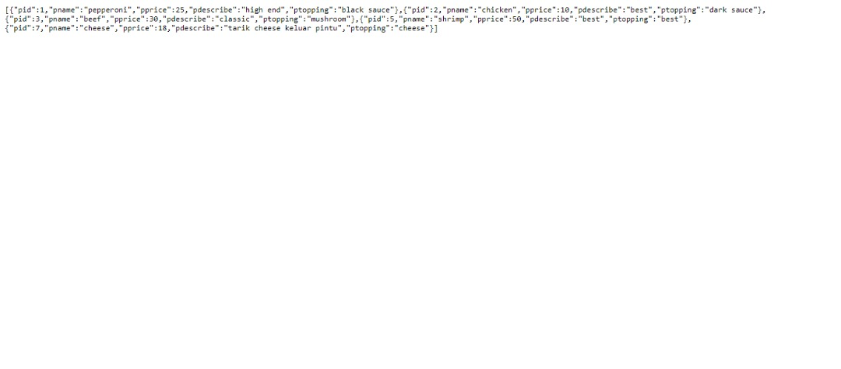

Figure 3.1 shows the information of products.

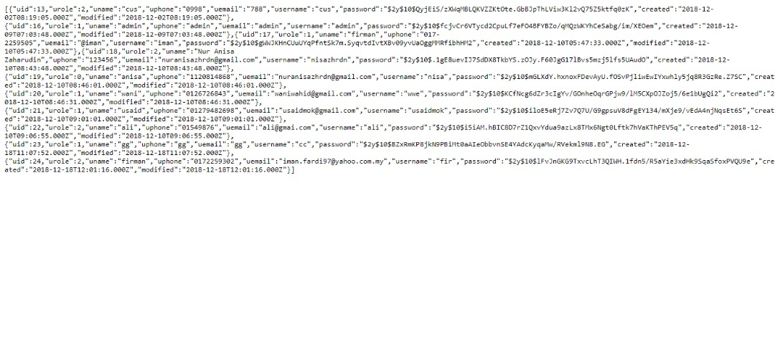

Figure 3.2 shows the information of the users.

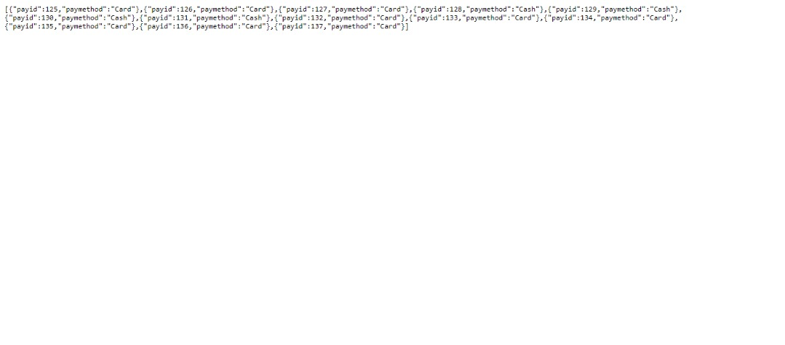

Figure 3.3 shows the information of the payment method.

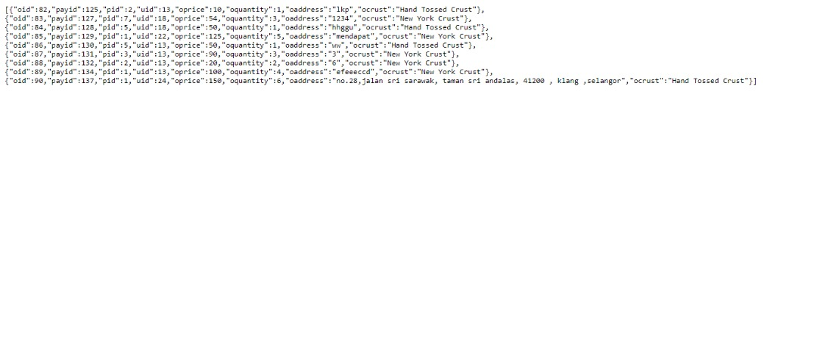

Figure 3.4 shows the information of the orders.